**Prepare/Support Product Test**

**Module Description**

During this module you will perform final smoke testing from within the User Interface, correct any defects and ensure that the code is fixed.

**Time Warp Presentation**

Click the link to launch the [Module 47 Time Warp Presentation](https://accenture.desire2learn.com/content/enforced/9406-Pending/W4_Participant_Materials/Module_47/ADF_2_0_Java_M47_TimeWarp_PD.pptx?_&d2lSessionVal=YnoL4daZGC8ne2RyGf0cWMrk8).

**Scenario**

The project team has successfully completed the assembly test for Release 2 and now it is time to start Product Test Readiness (or "Smoke") Testing. This testing will allow your team to make sure the application build is stable enough for product test.

Your team will also need to figure out what to test in the application to verify its readiness for Application Product Test. You will need to review the updated Product Test TCERs and find the appropriate TCERs to test the entire application before Product Test begins. Once those TCERs are determined, completing Product Test Verification testing will require you to test these TCERs by manually executing the application from the UI.

Once Product Test Verification is complete, your team will help to deploy the application to the test environment so that the test team can conduct the application product test. While the application product test is running, your team will play the role of fix-it team, as it receives defects and makes fixes.

**ADM Activity Context Diagram**

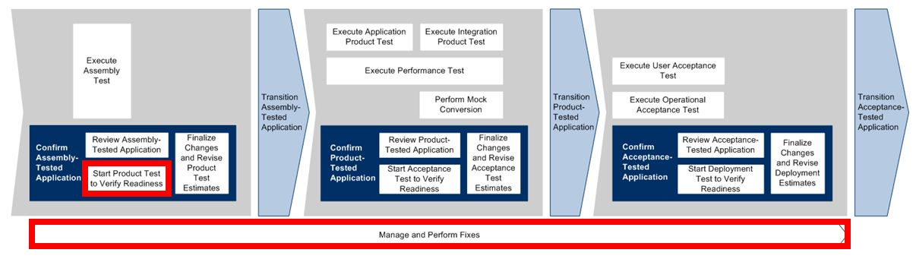

**Roles**

|  |  |  |  |
| --- | --- | --- | --- |
| **Role** | **ADM Task** | **ADM Responsibility** | **Description** |
| Developer | 5723 – Start Product Test to Verify Readiness  5790 – Manage and Perform Fixes | Primary Performer (for ADM task 5723)  Primary Performer (for ADM task 5790) | Performs Product Test Readiness Testing on the application.  Reviews any defects that were communicated by the Test Team, assesses the defects and, if required, corrects the application code to remove the defect. |
| Team Lead | 5723 – Start Product Test to Verify Readiness  5790 – Manage and Perform Fixes | Primary Performer (for ADM task 5723)  Primary Performer (for ADM task 5790) | Reviews the defects, assesses the complexity and validity of the defect, and assigns the defect to members of the fix-it team.  Delegates portions (screens) in the application to members of the team to perform Product Test Readiness testing. |
| Test Team | 5723 – Start Product Test to Verify Readiness  5790 – Manage and Perform Fixes | Primary Performer (for ADM task 5723)  Additional Performer (for ADM task 5790) | Executes the product test and communicates defects to the fix-it team (i.e., the Application Build Team). |

**Participant Instructions**

**Prepare for Product Test**

**Team Lead**

1. Launch the Use Case and Product Test work products for Release 2:

[Register Visitor (UC1)](https://accenture.desire2learn.com/content/enforced/9406-Pending/NCCC_Project_Work_Products/3a_App_Analysis/Release_2/UseCase_FERS_UC1_RegisterVisitor_R2_REF.docx?_&d2lSessionVal=YnoL4daZGC8ne2RyGf0cWMrk8)  
[Login Visitor (UC2)](https://accenture.desire2learn.com/content/enforced/9406-Pending/NCCC_Project_Work_Products/3a_App_Analysis/Release_2/UseCase_FERS_UC2_LoginVisitor_R2_REF.docx?_&d2lSessionVal=YnoL4daZGC8ne2RyGf0cWMrk8)  
[Update Visitor (UC3)](https://accenture.desire2learn.com/content/enforced/9406-Pending/NCCC_Project_Work_Products/3a_App_Analysis/Release_2/UseCase_FERS_UC3_UpdateVisitor_R2_REF.docx?_&d2lSessionVal=YnoL4daZGC8ne2RyGf0cWMrk8)  
[Register for Event (UC4)](https://accenture.desire2learn.com/content/enforced/9406-Pending/NCCC_Project_Work_Products/3a_App_Analysis/Release_2/UseCase_FERS_UC4_RegisterForEvent_R2_REF.docx?_&d2lSessionVal=YnoL4daZGC8ne2RyGf0cWMrk8)  
[Unregister from Event (UC5)](https://accenture.desire2learn.com/content/enforced/9406-Pending/NCCC_Project_Work_Products/3a_App_Analysis/Release_2/UseCase_FERS_UC5_UnregisterFromEvent_R2_REF.docx?_&d2lSessionVal=YnoL4daZGC8ne2RyGf0cWMrk8)   
[View Events (UC6)](https://accenture.desire2learn.com/content/enforced/9406-Pending/NCCC_Project_Work_Products/3a_App_Analysis/Release_2/UseCase_FERS_UC6_ViewEvents_R2_REF.docx?_&d2lSessionVal=YnoL4daZGC8ne2RyGf0cWMrk8)  
[Search Events List (UC7)](https://accenture.desire2learn.com/content/enforced/9406-Pending/NCCC_Project_Work_Products/3a_App_Analysis/Release_2/UseCase_FERS_UC7_SearchEventsList_R2_REF.docx?_&d2lSessionVal=YnoL4daZGC8ne2RyGf0cWMrk8)  
[Sort Events List (UC8)](https://accenture.desire2learn.com/content/enforced/9406-Pending/NCCC_Project_Work_Products/3a_App_Analysis/Release_2/UseCase_FERS_UC8_SortEventsList_R2_REF.docx?_&d2lSessionVal=YnoL4daZGC8ne2RyGf0cWMrk8)

[Product Test Cycle Control Sheet](https://accenture.desire2learn.com/content/enforced/9406-Pending/W4_Participant_Materials/Module_45/Prod_TestCycle_FERS_R2_REF.xlsx?_&d2lSessionVal=YnoL4daZGC8ne2RyGf0cWMrk8)  
[Product Test Scenarios](https://accenture.desire2learn.com/content/enforced/9406-Pending/W4_Participant_Materials/Module_45/Prod_TestScen_FERS_R2_REF.xlsx?_&d2lSessionVal=YnoL4daZGC8ne2RyGf0cWMrk8)  
[Product Test Conditions and Expected Results](https://accenture.desire2learn.com/content/enforced/9406-Pending/W4_Participant_Materials/Module_47/Prod_TestCond_FERS_R2_REF.xlsx?_&d2lSessionVal=YnoL4daZGC8ne2RyGf0cWMrk8)

2. If needed, open the Change Request and review the details.  
  
3. Given the Change Request details, review the Use Cases and find new key Use Cases that represent critical scenarios to test the Readiness of the Application for the Product Test.  
  
4. Assign new critical scenarios (including the scenarios from Release 1) to team members to test. You may assign Use Case(s) to yourself.  
  
**Developer**1. Launch the Use Case and Product Test work products for Release 2 using the links above in Step 1.  
  
2. Review the Use Cases that the Team Lead assigned you to test for the Product Readiness Test.

a) Open the team's Release 1 Product Readiness Test Scenarios and save it to a new filename for use with Release 2, as described above.

b) Open the team's Release 1 Product Readiness Test Conditions and Expected Results and save it to a new filename for use with Release 2, as described above.

c) Find the test scenarios that test the key Use Cases in the TE583 Product Test Scenarios document and add them to the Release 2 Product Readiness Test Scenarios work product.

d) Add the test conditions associated with the previously chosen test scenarios to the Release 2 Product Readiness Test Conditions and Expected Results work product.

3. Within Eclipse, run the application and manually execute the previously chosen test conditions by starting the application in your internet browser from the login page.

4. If any defects are found, be sure to correct the issue or request a teammate to correct it (if they are the author of the affected class).

5. Once the Management issues a 15 minute warning that the system test will need to start, check in all the code and ensure that the build can be recreated successfully.

6. The Team Lead must communicate to the Management that the team is ready to support the Product Test.

**Support Product Test**

1. The Test team will send you a list of defects after a run of your application. Go to the [Master Practice Primer](https://accenture.desire2learn.com/content/enforced/9406-Pending/NCCC_Project_Work_Products/1_PM/ADF_Java_2_0_Master_Practice_Primer_REF.docx?_&d2lSessionVal=YnoL4daZGC8ne2RyGf0cWMrk8) document and review the Defect Management section to understand the process to be followed for monitoring and closing defects.

a) Ask questions if you do not understand the defects by changing the status and sending it back to the test team with your questions.

b) Otherwise, make fixes to the code and re-unit test and regression test (product test the code and surrounding functionality to make sure everything else is working).

c) Update the status of the defects accordingly once fixed code is tested and confirmed to be corrected and the new code meets the Application Development Standards.

2. **Team Lead Only** - when all defects appear to be fixed, notify the test team by email, providing the updated defect list.

***NOTE: All defects must be fixed and closed by the test team by end of the module.***

**Hints and Tips**

* Perform some exploratory testing. Bugs typically move in groups; therefore, if you find one, you may want to look for more in that area.
* Fix as many defects as possible before deploying another build to the test environment.